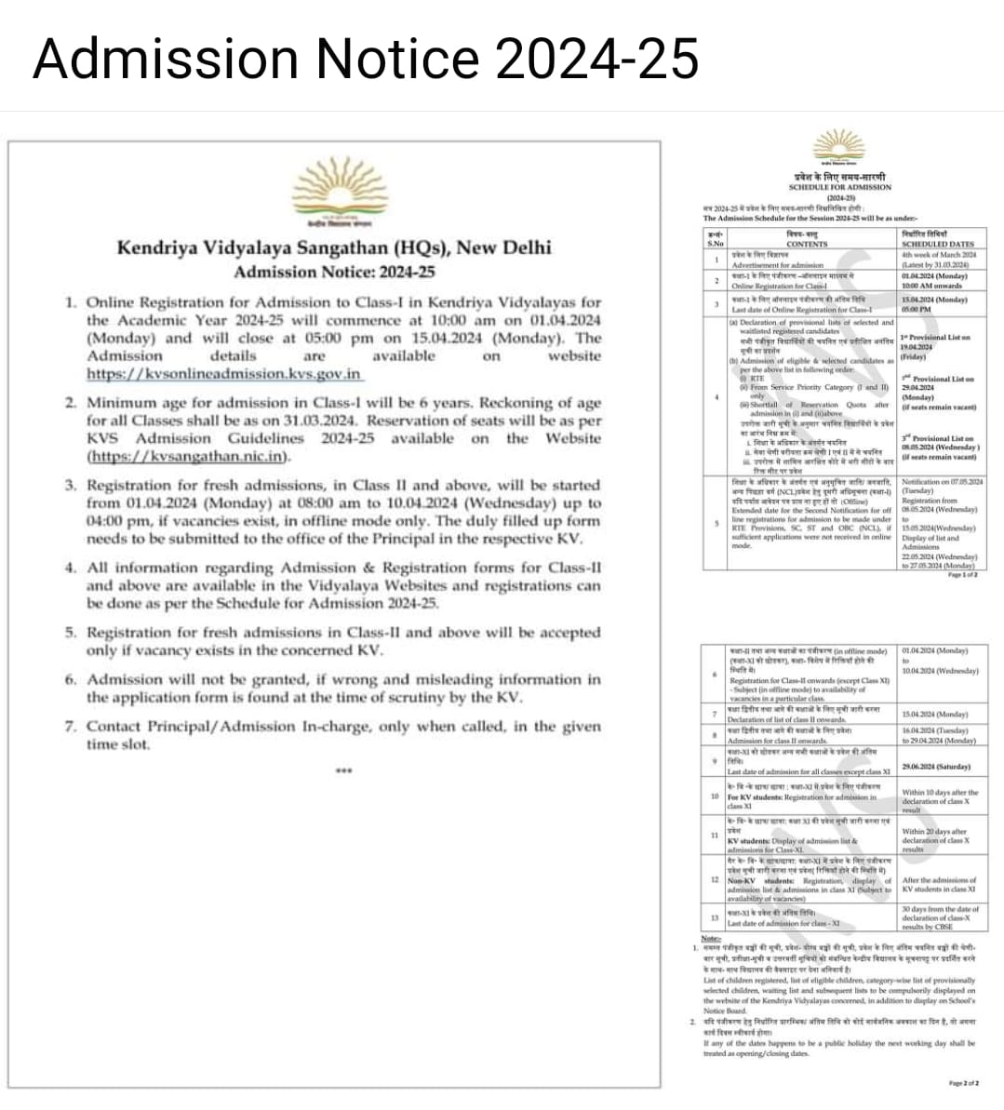

Admission Notice for Class I (2024-25)

Online Registration for Admission to Class-I (2024-25) in Kendriya Vidyalayas will commence at 10:00 am on 01.04.2024 (Monday) and will Closed at 05:00 PM on 15.04.2024 (Monday). The admission details are available on the website:
https://kvsonlineadmission.kvs.gov.in
OR
https://kvsonlineadmission.kvs.gov.in/index.html

