Ek Bharat Shresth Bharat activities

The activities under Literary fest were conducted during November 2019 and December 2019 before Winter breaks.

The photographs related to the activities are attached herewith.

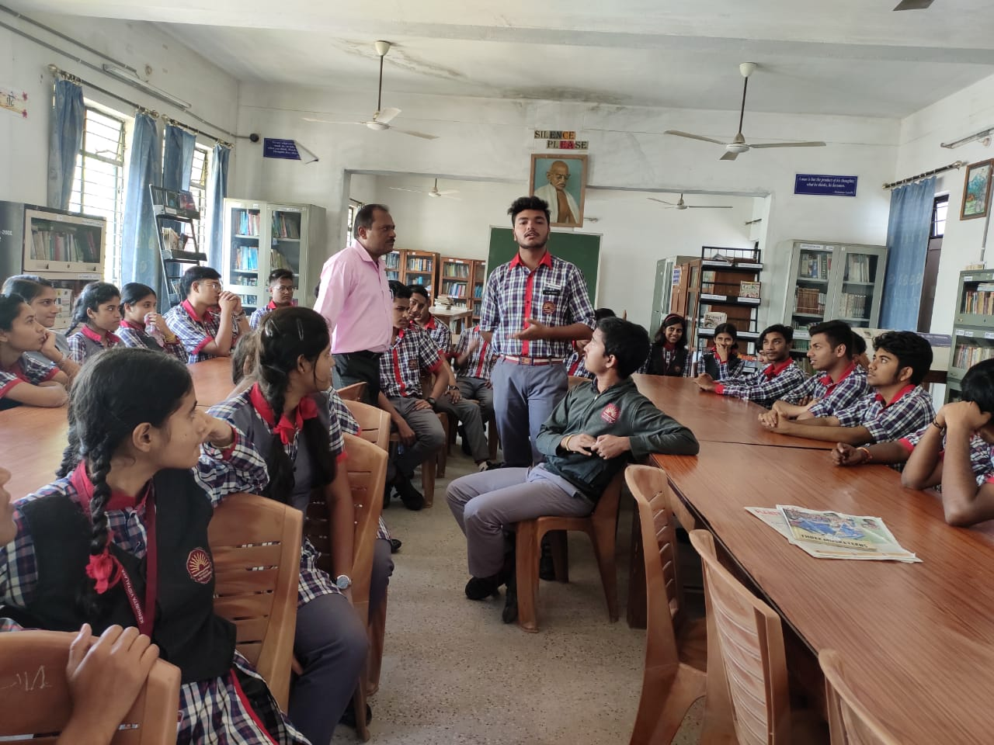

Extempore competition

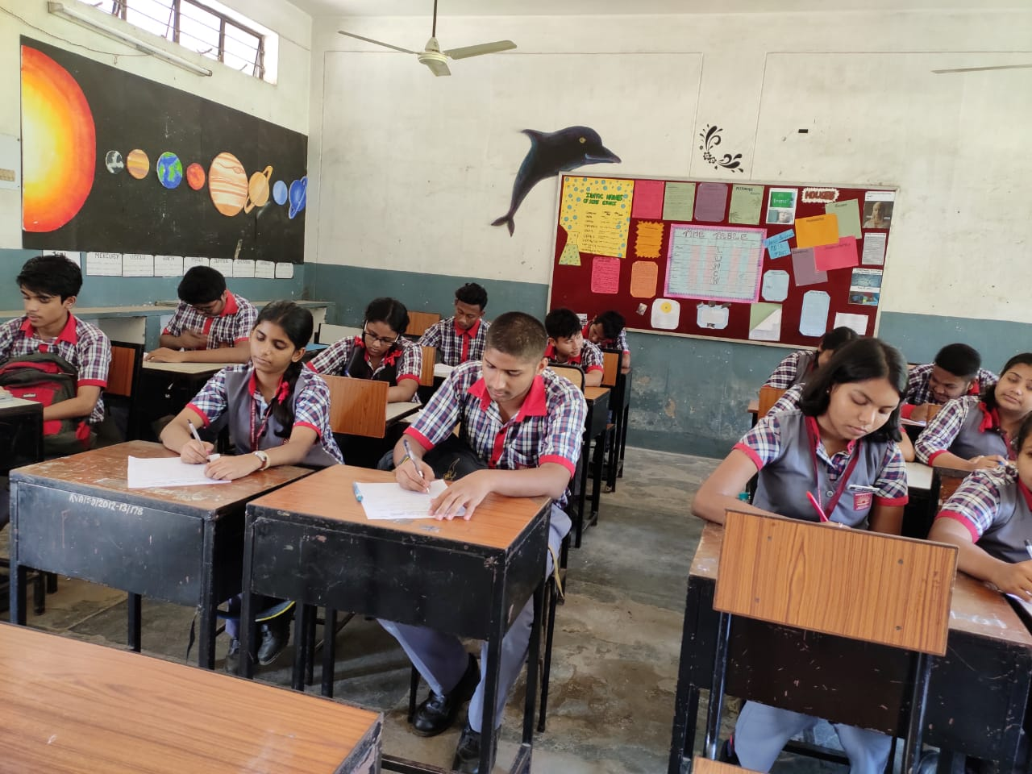

Written Quiz
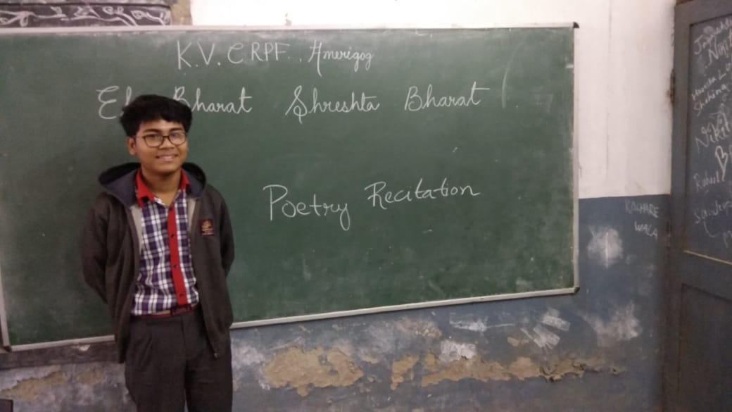
Poetry Recitation

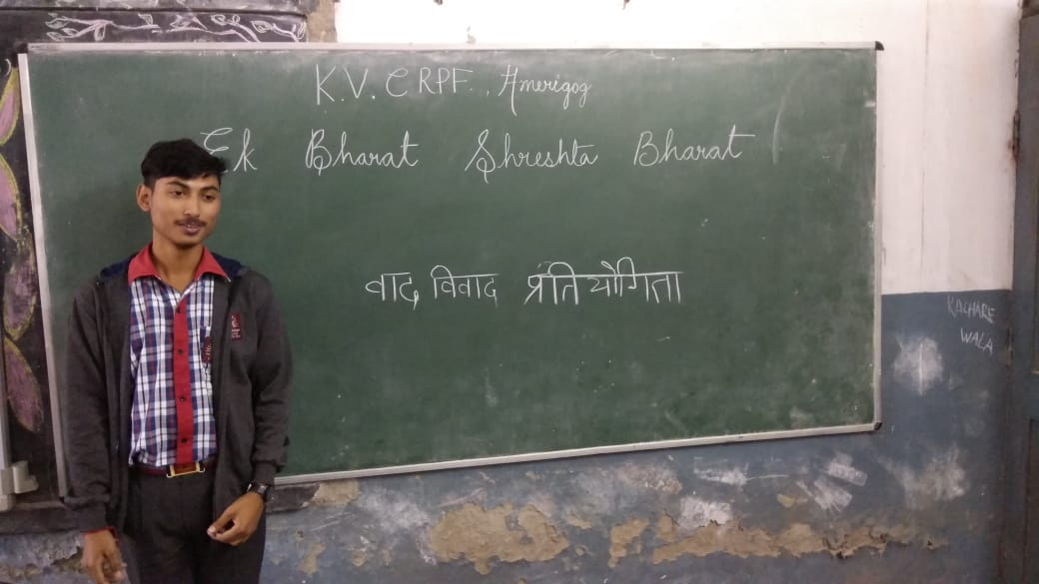
Hindi Debate

