dent Achievers
Student Achievers for the Session 2013-14
1. Student achievements in Games & Sports for Regional & National 2013-14
Sr.No. | Photo | Details
1 | 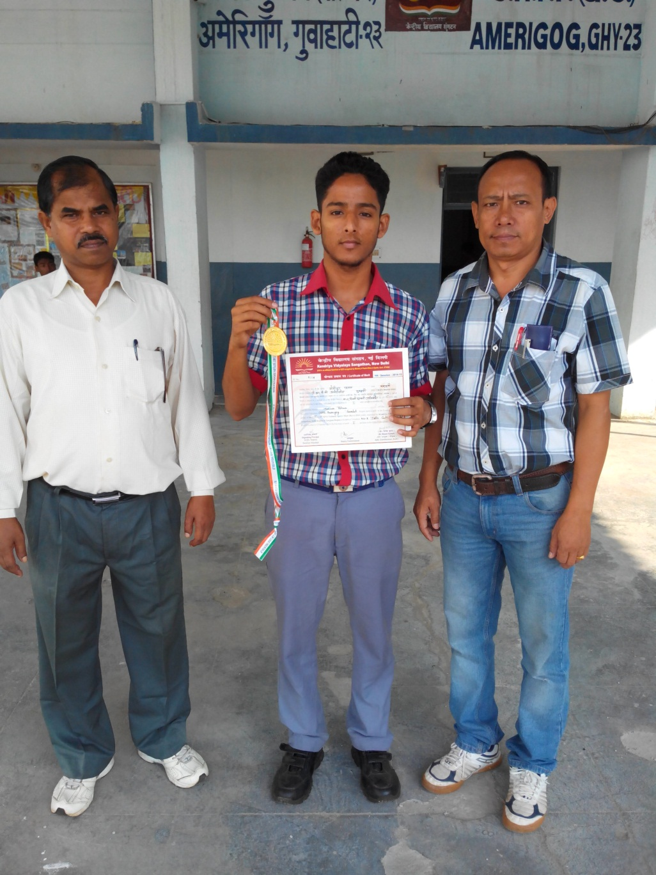 | Master Mominur Rahman, class XII C won gold medal in 45th KVS National Sports Meet (Boys U-19) 2014 Taekwondo
2 |  | Master Ritesh Singh, Class IX A and Master Bipin Kumar, Class X A received gold medal & appreciation certificate for excellent performance at National Level Science Talent Search Examination 2013 organised by Unified Council on 27/01/2013.
3 | 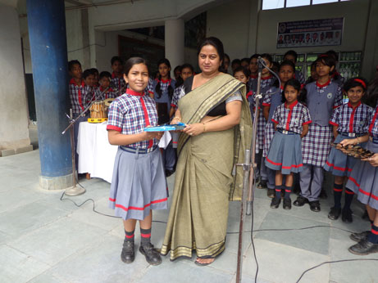 | Mayuri Goswami, Class VII B secured Ist (Group B) position on Earth Day Celebration 2013 held at Regional Science Centre, Guwahati.
4 |  | Vishek Kumar Jha, Class XII A got 1st Position in the KVS 41st JNSMEE 2014 held at KV Nehu, Shillong
5 |  | Jasnpreet Kaur, Prabha Kumari of class XI won Silver medal (Second Position) at 44th KVS National Sports Meet (Girls) 2013-14.

Achievement, of the Olympiads (Maths/Physics/Chemistry/Biology etc.), N.T.S.E. etc
1 | .

- KVS RO

- KVSANGATHAN

- UBI Online Fee Coll

- CBSE

- NCERT

- Admission Guidellines

- Transfer Policy

- Sakshat

- Shiksha

- CBSE Norms of Affiliation

- Annual Report
Tuesday 30 th October 2018
:
:
12
:
26
:
26
You are Visitor No. :
073889
Hindi Site Visitors :
050694
RAMCOM. SOLUTIONS.
Website Designed by RCS mail: info@rcsindia.co.in Best Web Hosting Provided by India Web Hosting

