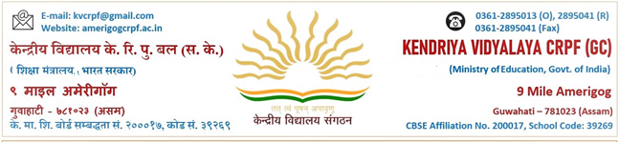
F.84/KVS/CRPF/CONDEMNATION/2021-22 दिनांक: -24.03.2022
AUCTION NOTICE
It is notified for general public that an auction of condemned articles of KendriyaVidyalya CRPF Amerigog is to be done on 29.03.2022 at 11.00 AM in Vidyalaya premises.
The terms and conditions and details of items to be auctioned are given below:
Terms and conditions:
- The items for auction can be seen on working day between 25.03.2022 to 28.03.2022 at 01.00 PM in Vidyalaya.
- The Successful highest bidder is required to deposit the 50% of the sale price on the spot which is non-refundable and the balance amount should be submitted on the next day. If the bidder fails to pay the balance amount of sale price on next day, the goods will be sold to the next higher bidder on the next day.
- The bidder shall abide by the rules to be declared at the time of auction.
- The teacher supervising the auction/Principal of the Vidyalya will reserve the right of refusing without assigning any reason, the offer of the highest bidder, if in their opinion it is not reasonable.
- KVS employee and their relatives are not allowed to participate in the Auction.
- The In-Charge/Stock holder of the below department will also present at the time of auction.
- Reserve price will be revealed only at the time of auction.
- Once the goods are sold in the auction, it will not be taken back.
- Auction will take place amongst the bidders who are present at the appointed time & venue.
- The auctioned goods will have to be removed immediately otherwise the school will not be responsible for any loss. Interested parties are requested to attend the auction. Only cash will be accepted towards the price of the auctioned articles/items.
- The undersigned reserves the right to postponed/cancel the auction without assigning any reason at any stage.
List of condemned items to be auctioned on 29.03.2022

SL. NO. | DEPARTMENT | AMOUNT
01 | Computer Sciences | 1521744
02 | Chemistry | 19924
03 | BS&G | 100880
04 | Library | 69907
05 | Teaching Aids | 10910
06 | Music | 75315
07 | SUPW | 49748

PRINCIPAL
Copy to; -
- The Deputy Commissioner, KVS RO Guwahati for information.
- The Chairman, VMC, KV CRPF(GC) Amerigog for information.
- Principal to All KVs of Guwahati Region with a request to display in their Vidyalaya notice boards for publicity.
- Branch Manager SBI, CRPF Amerigog
- Post Office Master, CRPF Amerigog
- CMO CH Hospital, CRPF Amerigog
- CPC Canteen In-charge, CRPF Amerigog

